CS 340 README | Nicholas Feero

About the Project/Project Title
Project Title: CRUD Operations using Python and MongoDB
In my project, I’m developing a software application that implements create, read, update, and delete (CRUD) operations in existing data. To perform these actions, my project will be utilizing MongoDB for database access and Python scripts for the CRUD operations.

Motivation
My project will serve to identify dogs that are good candidates for search-and-rescue training. By creating and maintaining my project, I’ll provide reliable results for potential dogs that can be trained to find and help rescue humans or other animals in specific rescue conditions.

Getting Started
To establish a functional version of this project on a local system, follow these steps:
- Install MongoDB on your device.
- Create a Mongo Database with your data set and label it with a simple but representative name.
  - For example, our data set of Austin Animal Control is labeled as AAC.
- Create a user with read/write permissions.
  - Ensure to remember the username and password of the created user
- Determine if you’re in the correct directory with your data set. If not, assign the correct directory.
- Import the data from your data set using the appropriate MongoDB import tool.
- Sign in to the user you created with read/write permissions.
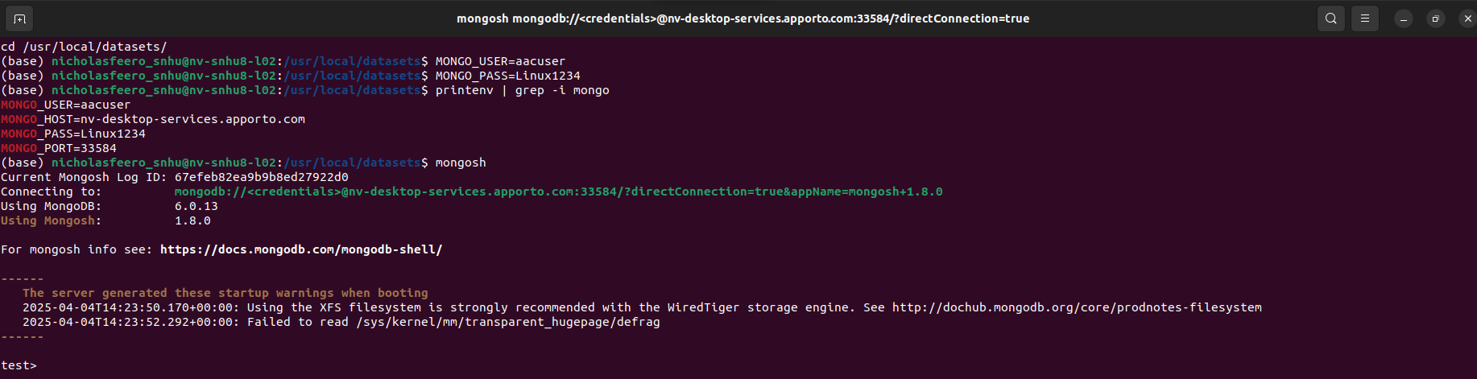
- Launch the Mongo shell and access (use) the database.
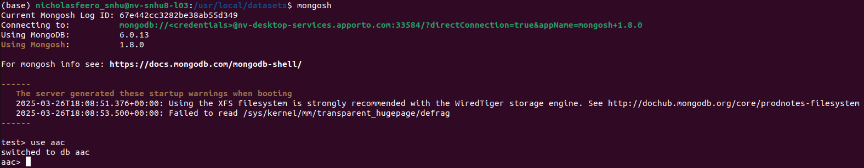
- After establishing your MongoDB Database, initialize the MongoClient in your Python script.
  - Ensure that your “__init__” function is updated with the correct values for your local MongoClient. This includes your username, password, host, port, database, and collection.
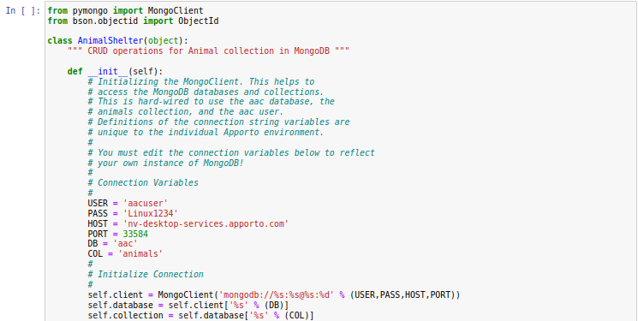

- Finally, you can begin implementing your CRUD operations in your Python script to begin interacting with your MongoDB database.

Installation
The tools you’ll need to use the software are MongoDB, Python, and Jupyter Notebook. You’ll need MongoDB for establishing your data set as a database, Python for the creation of Py modules, and Jupyter Notebook to write Python test scripts that interact with the database. The PyMongo driver is utilized to connect your instance of Mongo with Python, which allows users to manipulate and sample the Mongo database through Python script.

MongoDB:
MongoDB’s installation for various operating systems can be found here. This is the MongoDB Community edition, which is an open-source and free version of MongoDB that has plenty of community support.
Python:
Make sure to install the latest version of Python. The version of Python that this project was created on is Python 3.9. To find the latest version of Python, click here.
Jupyter Notebook:
Jupyter Notebook can be installed via the Python Package Index. To install Jupyter Notebook, follow this method by clicking here.

Usage

Code Example
Create Function:
Define the create function and the parameters. Then, create an if statement that determines if the value for the data parameter is zero. If data is not equal to zero, define a variable with the inserted document of data, which should be a dictionary. If the insertion variable doesn’t equate to zero, return True. If it equates to zero, return false. Otherwise, an exception occurs due to an empty data parameter.
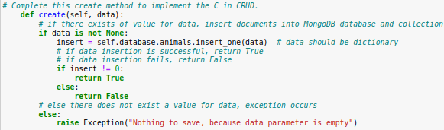

Read Function:
Define the read function and the parameters. Then, create an if statement that determines if the value for the data parameter is zero. If data is not equal to zero, return the associated dictionary document from the MongoDB database and collection. Otherwise, an exception occurs due to an empty data parameter.
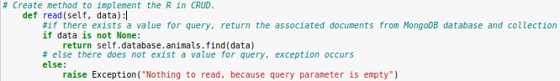

Update Function:
Define the update function and the parameters. Then, create an if statement that determines if the value for your search data parameter is zero. If the search data parameter is not equal to zero, define a variable using the update_many() function that uses the search data value to update documents (denoted with the update data parameter) containing the search data value. Once this is done, return the variable and specify the modified count. If the search data parameter is zero, an exception occurs due to an empty search data parameter.
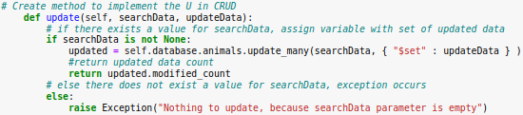

Delete Function:
Define the delete function and the parameters. Then, create an if statement that determines if the value for your delete data parameter is zero. If the delete data parameter is not equal to zero, define a variable using the delete_many() function that uses the delete data value to delete documents matching the value. Once this is done, return the variable and specify the deleted count. If the delete data parameter is zero, an exception occurs due to an empty delete data parameter.
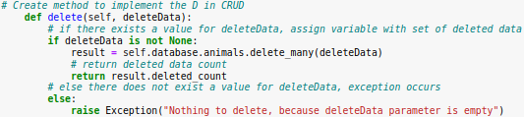

Tests

Before creating the test code for each function, I had to import the AnimalShelter class from the .py module that contains our functions. Then I set a variable to reference the module class. Finally, I established example animal data to be used for testing.

Create Test:
Create a variable that calls the create function from the AnimalShelter class with the parameter of our example animal data. Then, print the results. If the entry can be successfully inserted into our database, we should see an output of True. If the entry failed to be inserted into our database, we should see an output of False or an Exception.

Read Test:
Create a test variable that establishes what the read function will be examining. Then, create a variable that calls the read function from the AnimalShelter class with the parameter of our test variable. Then, to iterate over our database, implement a for-loop to print all documents in our database that contain of our test variable.
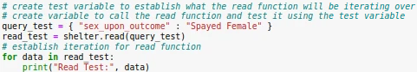

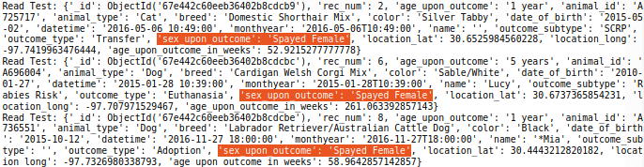

Update Test:
Create a test variable that calls the update function from the AnimalShelter class. Within this function, establish the parameter values for search data and update data respectively. Once this is done, print the variable to receive the output.

Delete Test:
Create a test variable that calls the delete function from the AnimalShelter class. Within this function, establish the parameter value for delete data. Then, print the variable to receive the output.

NOTE: The update and delete functions have the capability to delete many documents, however, we’re performing actions unique to the established example data. Thus, our tests only affect one document.

PROJECT TWO

Functionality
The required functionality for this project is to create an interface via Dash where users can access, manipulate, and query datasets using MongoDB, Python, and Jupyter Notebook. In my scenario, I’m a software engineer who’s working for Global Rain. Our client, Grazioso Salvare, is an innovative international rescue-animal training company and I’ve been assigned as the lead developer for their request. They want to create a software application that can work with existing data from animal shelters to identify and categorize available/ideal dogs for rescue training. To create an effective software application, the specifications and functionality that I need to meet are that I brand the software application accordingly, I make interactive filter options to sort the dataset by desired rescue criteria, and I implement a dynamic geolocation map chart and another dynamic chart (in this case, a pie chart) that responds to the filtering options. The final product and interface will resemble this:
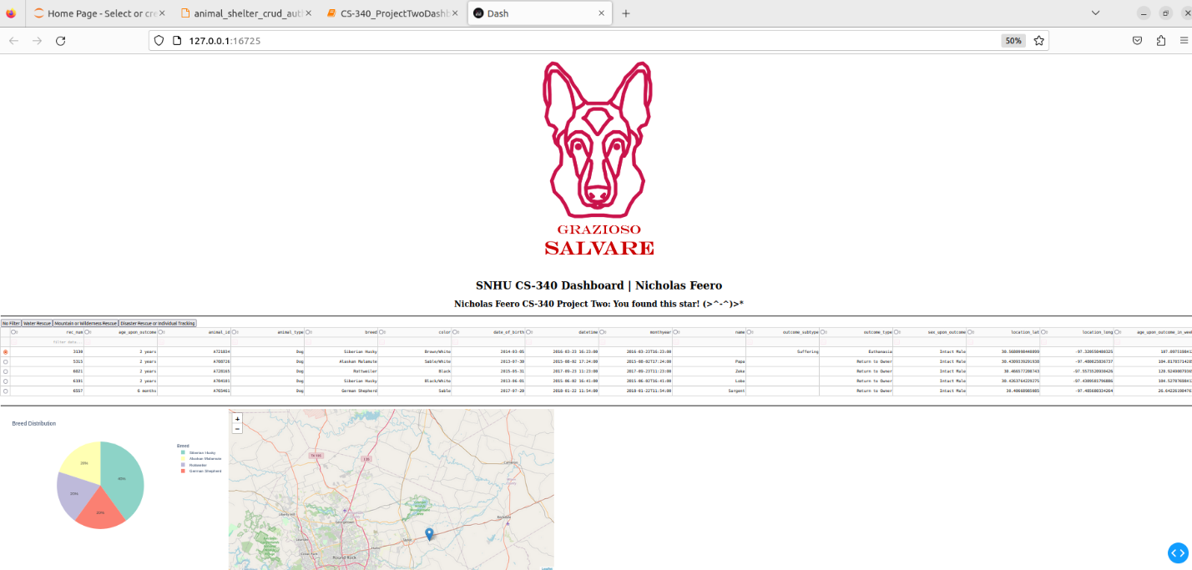

Installation
The tools you’ll need to use the software are MongoDB, Python, and Jupyter Notebook. You’ll need MongoDB for establishing your data set as a database, Python for the creation of Py modules, and Jupyter Notebook to write Python test scripts that interact with the database. The PyMongo driver is utilized to connect your instance of Mongo with Python, which allows users to manipulate and sample the Mongo database through Python script.

MongoDB:
MongoDB’s installation for various operating systems can be found here. This is the MongoDB Community edition, which is an open-source and free version of MongoDB that has plenty of community support.
Python:
Make sure to install the latest version of Python. The version of Python that this project was created on is Python 3.9. To find the latest version of Python, click here.
Jupyter Notebook:
Jupyter Notebook can be installed via the Python Package Index. To install Jupyter Notebook, follow this method by clicking here.

Finally, you’ll be utilizing the Dash framework throughout this project. Dash is a Python framework that assists in building interactive applications. By using Dash to display the interface, this grants the ability to incorporate geolocation maps, dynamic charts, interactive tables, and filter options for observing the dataset in many ways. To access the Dash framework, and to use the functions associated with it, you must set up Dash by importing it into your document/code.
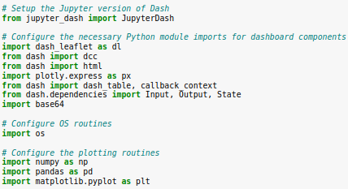

Steps
To establish a functional version of this project on a local system, follow these steps:
- Install MongoDB on your device.
- Create a Mongo Database with your data set and label it with a simple but representative name.
  - For example, our data set of Austin Animal Control is labeled as AAC.
- Create a user with read/write permissions.
  - Ensure to remember the username and password of the created user
- Determine if you’re in the correct directory with your data set. If not, assign the correct directory.
- Import the data from your data set using the appropriate MongoDB import tool.
- Sign in to the user you created with read/write permissions.

- Launch the Mongo shell and access (use) the database.

- After establishing your MongoDB Database, initialize the MongoClient in your Python script.
  - Ensure that your “__init__” function is updated with the correct values for your local MongoClient. This includes your username, password, host, port, database, and collection.


- Once you’ve successfully initialized the MongoClient in your Python script, you’ll save the Python script as a .py file (if you haven’t already) and upload it to the Jupyter Notebook home page. This will allow for other files within Jupyter Notebook to utilize the Python file by importing it.

- Then, in a new .ipynb file, you’re going to create your dashboard script. To do this, you’ll need to import the necessary Dash files and your .py files.
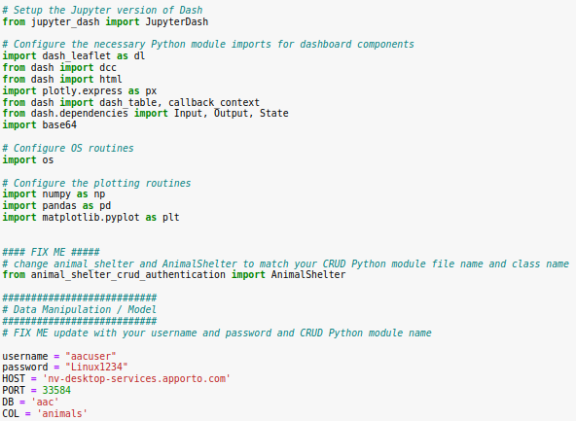
- Finally, you’ll need to instantiate your .py file’s class and create the script to access your dashboard.
- During this stage, you’ll be creating the code to populate specific data, observe data through different methods/charts, and effectively display the sorted data.
- At this point, you’ll be able to add any functions, charts, or filters that apply to your scenario! Once you run your .ipynb file, you’ll receive the output of your Dash app and you’ll be able to interact with your custom dashboard!

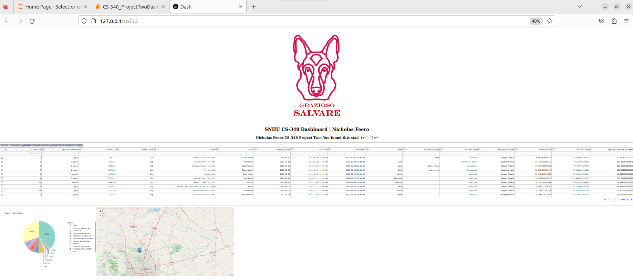
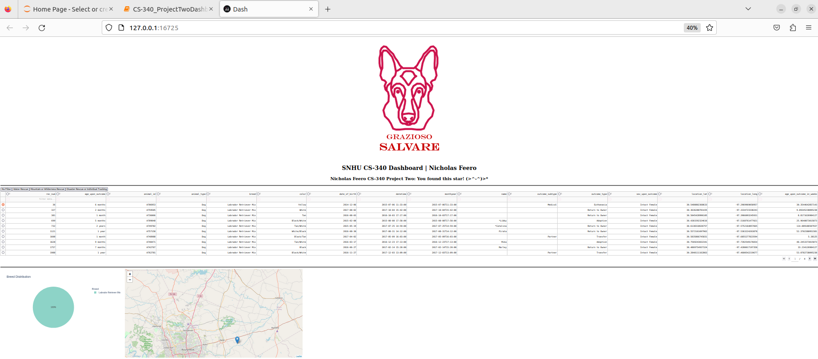
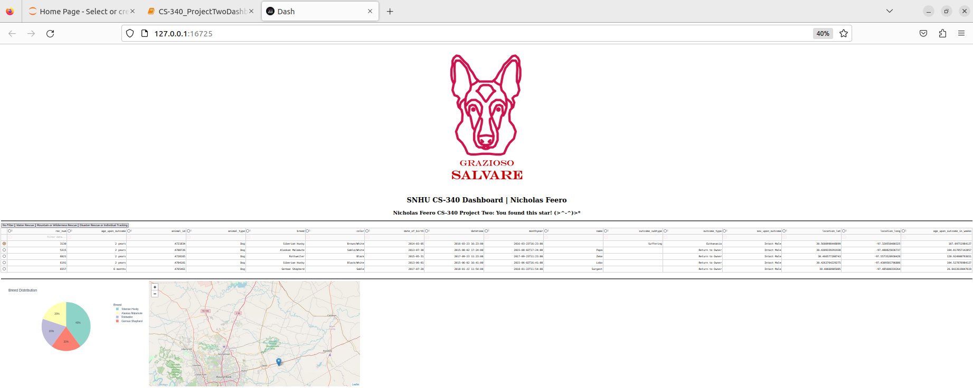
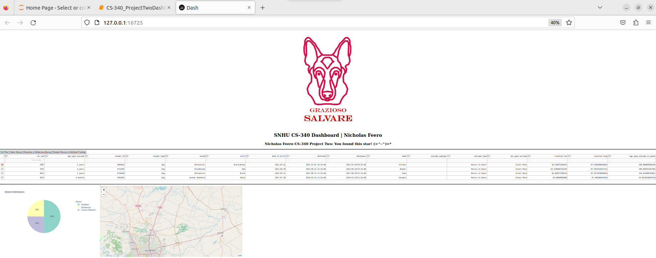

Challenges
The biggest challenge I faced in this process was determining how everything (MongoDB, Python, and Jupyter Notebook) interacted to produce a cohesive system. For me, there wasn’t a simple solution toward overcoming this challenge. I reviewed the course material, and I attempted online research, but ultimately how I overcame this challenge was through experimenting and trial-and-error. I was able to understand how these different tools interacted with each other by testing limits and isolating variables. This helped me understand what effect was caused by a change, and what changes created a certain effect. Once I was able to wrap my head around the tools’ roles in this project, I could tackle errors and logic in a faster, more productive way.

Contact
Nicholas Feero

